

 Integration of Sales*f*orce with DoubleClue using SAML

# Introduction

This guide is intended for users of Salesforce CRM who would like their employees to log in to Salesforce via DoubleClueMulti-Factor Authentication (MFA) using SAML 2.0. For more information on these products, please visit <https://www.salesforce.com/>.

Requirements:

* Salesforce Version Spring 19 or newer
* Salesforce-Account
* DoubleClue Enterprise Management-Systems (DCEM) with registered users matching employee-emails

# Preparing DCEM to be an Identity Provider

In order to prepare DCEM to be an Identity Provider, please see chapter 12 of “DCEM_Manual_EN.pdf”.

# Setting up Sales*f*orce CRM

1. Log into your Salesforce Organization Center at <https://login.salesforce.com>.
2. Click on the user icon in the upper right corner.
3. In the following dialogue choose under options „Switch to Salesforce Classic.“ You will then be forwarded to the classic Salesforce view.

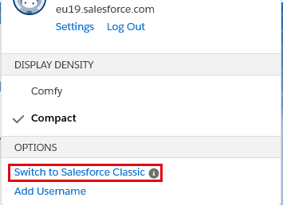

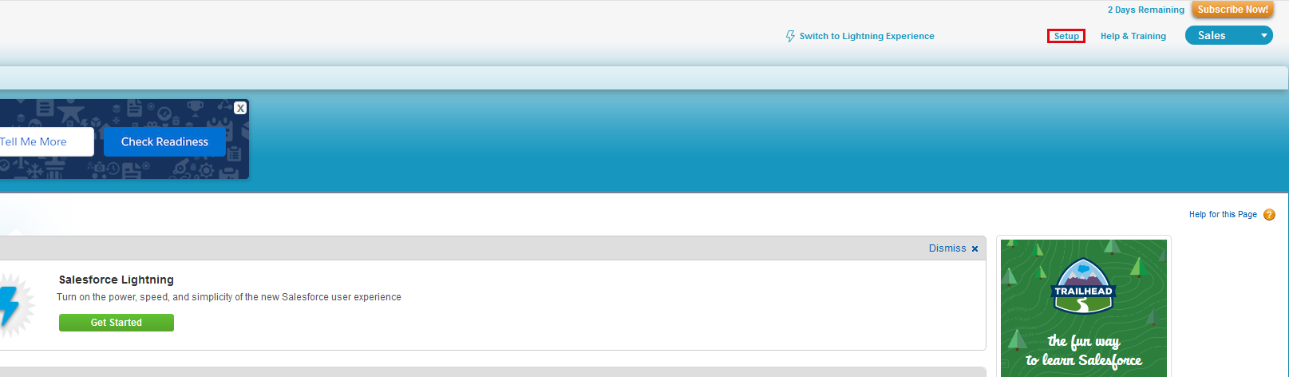

1. Go on „Setup“ on the right side oft he upper menu bar. Then use the Quick Search to search for „Single Sign-On Settings”.
2. Make sure that “SAML Enabled” is checked.

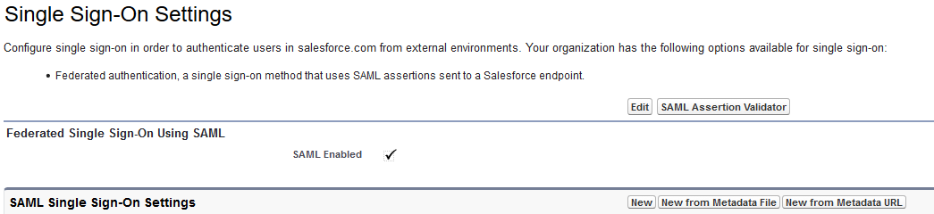

1. Click on “New from Metadata File” and choose the IdP-Metadata-XML-file, which you downloaded during the SAML-Setup (see chapter 12 of “DCEM_Manual_EN.pdf”).
2. Click on „Create“.
3. 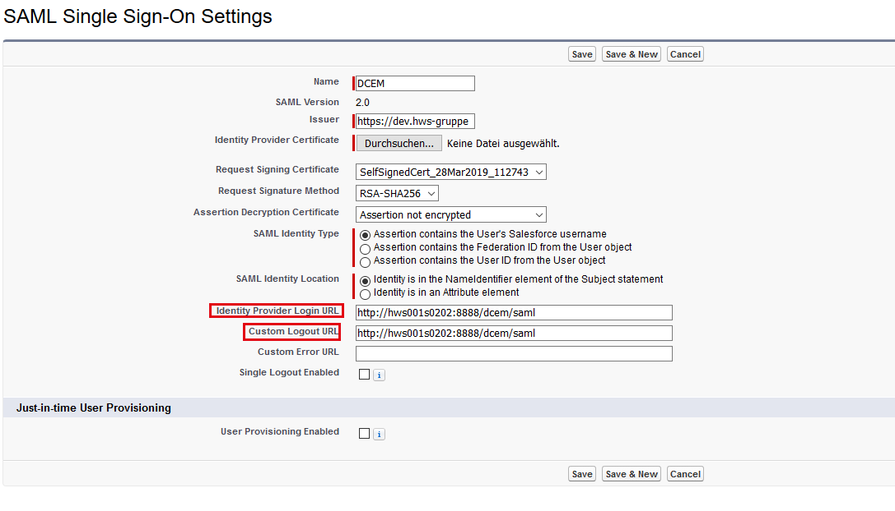Enter the SAML login URL into the „Identity Provider Login URL” and „ Custom Logout URL” fields. The other fields will be filled automatically after uploading the file. Click on “Save”

DCEM is now registered as an identity provider for Salesforce.

# Setting up Sales*f*orce as a Service-Provider for DCEM

1. Upload the XML-file from your Salesforce Organization Center. Navigate to the SAML

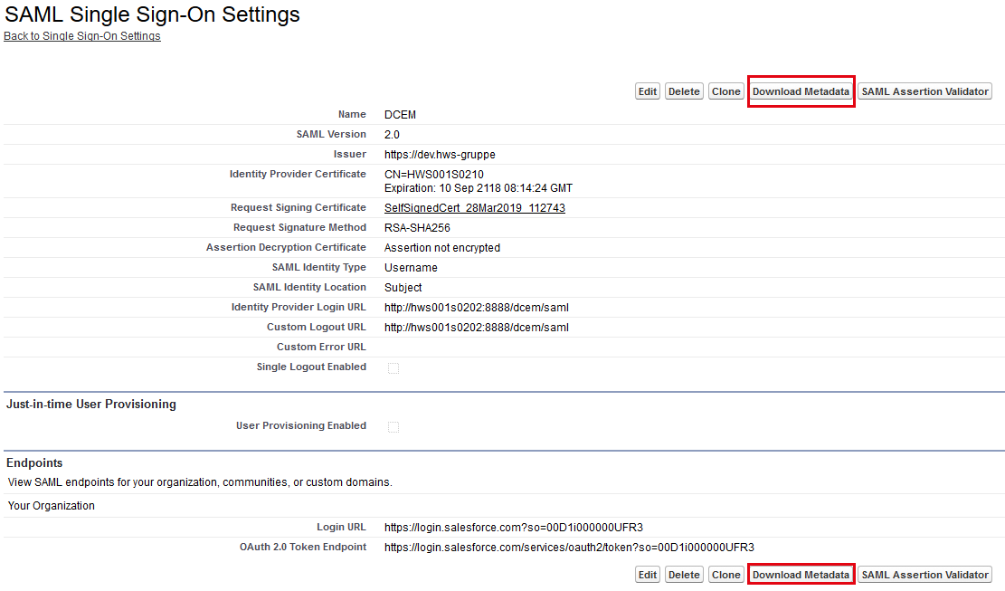Single Sign-On Settings as described under 3.

1. Click on the name of the file entry (most likely DCEM).
2. Click on „Download Metadata“.
3. Log into DCEM and select the SAML item in the menu on the left side of the screen.
4. Choose „SP Metadata“ and click on „Add“.
5. Choose „Custom“ in the dropdown menu of the following dialogue and click on „Continue“.
6. Upload the downloaded xml-file with the „Upload“-button.
7. Enter a unique and informative „Display Name“ like Salesforce.
8. Go to the Tab „Details“.
9. Choose „email“ in the „Expected Name ID Format“ dropdown menu.
10. Click on „OK“.

Salesforce is now registered as an ID provider for DoubleClue.